How to Run Java program on CMD

1. Check Java is installed or not

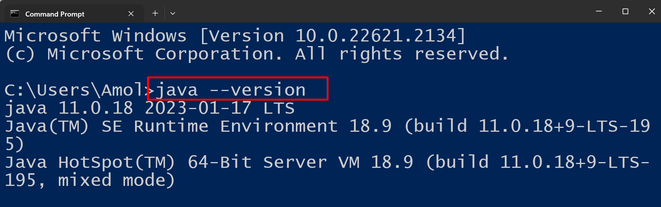

1. Create java program. Extension is .java

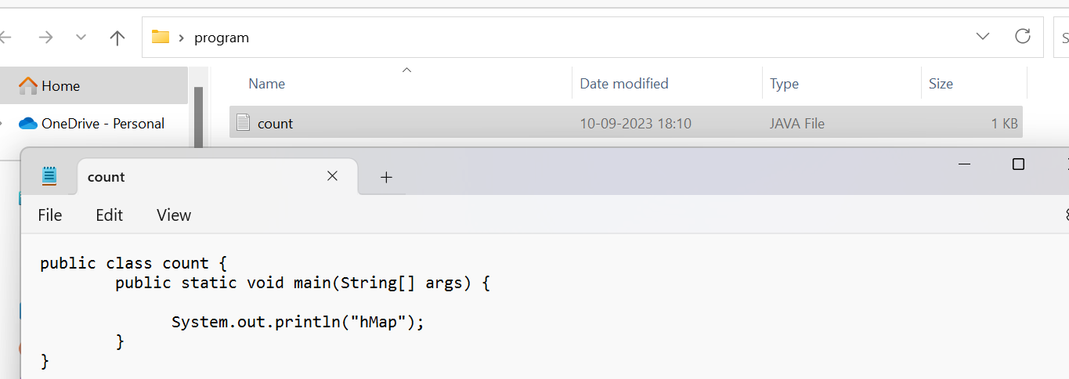

1. Go to the project location

Set the path of jdk bin first : one time activity

**To compile the Java program type the following command:**

**Javac ProgramName.java**

**To run the Java program, type the following command.**

**Java ProgramName**

